**E**stimation **A**nd **C**onfidence **I**ntervals

**Background**

In quality control processes, especially when dealing with high-value items, destructive sampling is a necessary but costly method to ensure product quality. The test to determine whether an item meets the quality standards destroys the item, leading to the requirement of small sample sizes due to cost constraints.

**Scenario**

A manufacturer of print-heads for personal computers is interested in estimating the mean durability of their print-heads in terms of the number of characters printed before failure. To assess this, the manufacturer conducts a study on a small sample of print-heads due to the destructive nature of the testing process.

**Data**

A total of 15 print-heads were randomly selected and tested until failure. The durability of each print-head (in millions of characters) was recorded as follows:

1.13, 1.55, 1.43, 0.92, 1.25, 1.36, 1.32, 0.85, 1.07, 1.48, 1.20, 1.33, 1.18, 1.22, 1.29

**Assignment Tasks**

**a. Build 99% Confidence Interval Using Sample Standard Deviation**

**steps:**

1. Calculate the Sample Mean and Sample Standard Deviation.
2. Determine the Appropriate t-Score.
   1. Degree of freedom (df)= n-1 = 15-1 = 14
   2. Confidence level 99% so 1-α = 2.576

3. Construct the confidence interval.

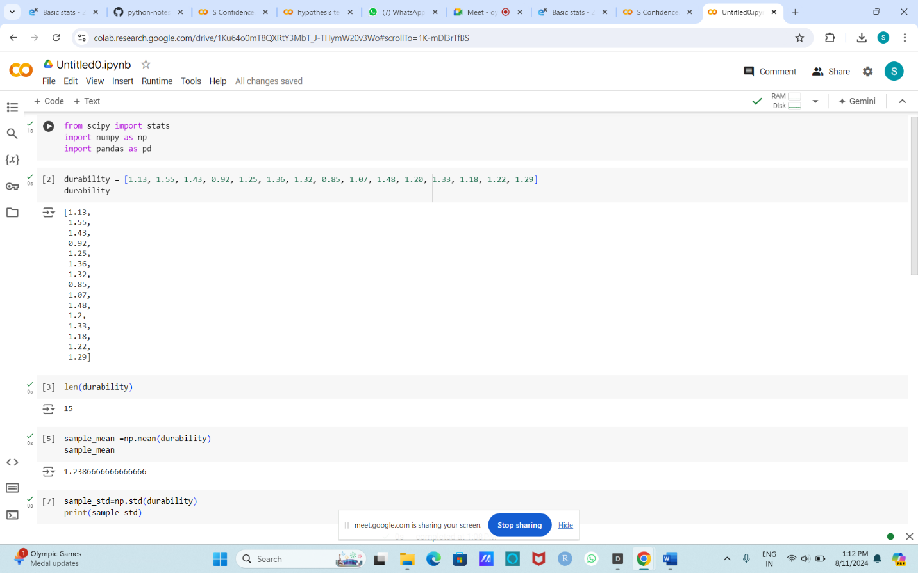

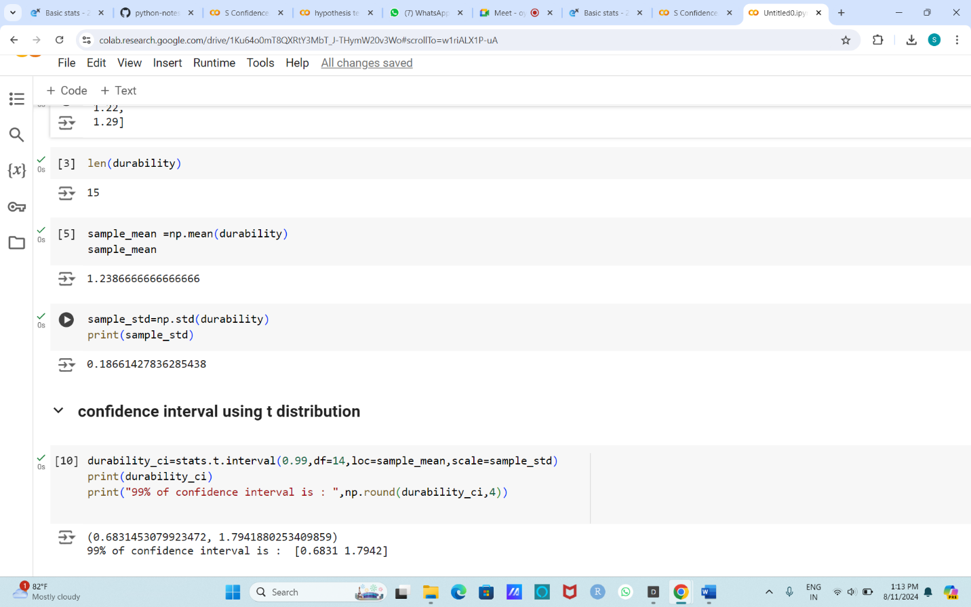

**Rationale for Using the t-Distribution**

**Sample Size:** With a small sample size (n < 30), the sample standard deviation may not perfectly estimate the population standard deviation. The t-distribution is more appropriate for small samples as it accounts for the added uncertainty in the estimation of the standard deviation.

**Critical Value:** The t-distribution has wider tails than the normal distribution, reflecting the increased uncertainty. This leads to a slightly larger margin of error, which is why the t-distribution is used instead of the normal distribution in such cases.

**Summary**

The 99% confidence interval for the mean number of characters printed before the print-head fails is approximately (0.6831, 1.7942). This interval means we are 99% confident that the true mean durability of print-heads lies within this range.

**b. Build 99% Confidence Interval Using Known Population Standard Deviation**

steps:

1. Calculate the Sample Mean and Sample Standard Deviation.
2. Calculate the population standard deviation = 0.2
   1. Confidence level 99% so 1-α = 2.576
3. Construct the confidence interval

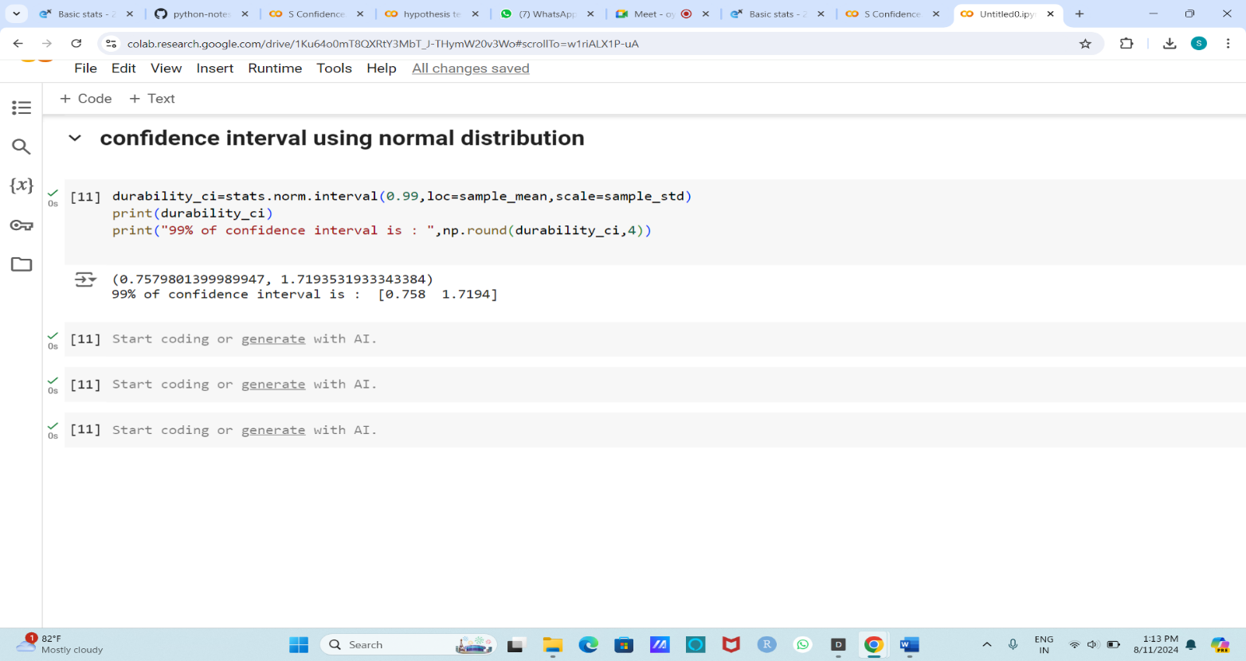

**Summary**

Given the known population standard deviation of 0.2 million characters, the 99% confidence interval for the mean number of characters printed before the print-head fails is approximately (0.758, 1.7194). This interval means we are 99% confident that the true mean durability of print-heads lies within this range.